Seed Bombs
Mix together:
- 1 scoop soil
- 1 scoop sand
- 1 scoop worm castings
- 1 scoop flour
- 1 scoop wildflower seeds
- Tbsp water
Mix until mixture comes together. Roll into gumball size balls. Place in egg carton to transport home while wet. Let dry completely.
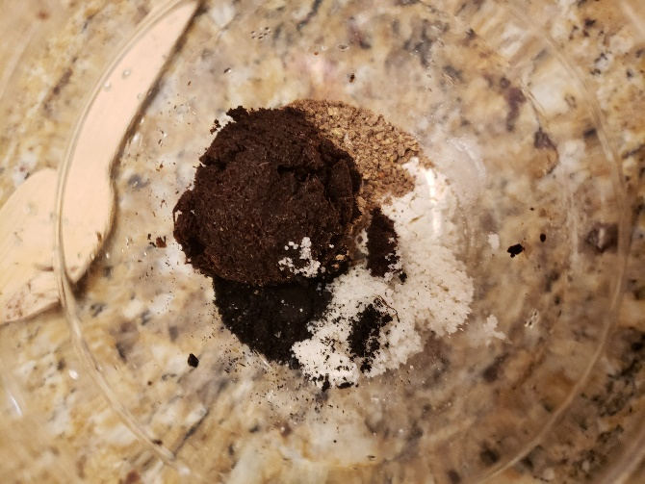
To use seed bombs: throw seed bombs wherever you think more wildflowers are needed! Seeds should have what they need to germinate without the need to dig a hole and plant them.

