To make a spiral, pinch the shirt in the middle and turn, tightly twisting the fabric around the center point. At the end you should have a disk like shape. Bind the spiral disk with elastic across the circle, dividing the disk into "slices" like a pie. Fill each slice with one color of dye on both the front and back side of the disk.
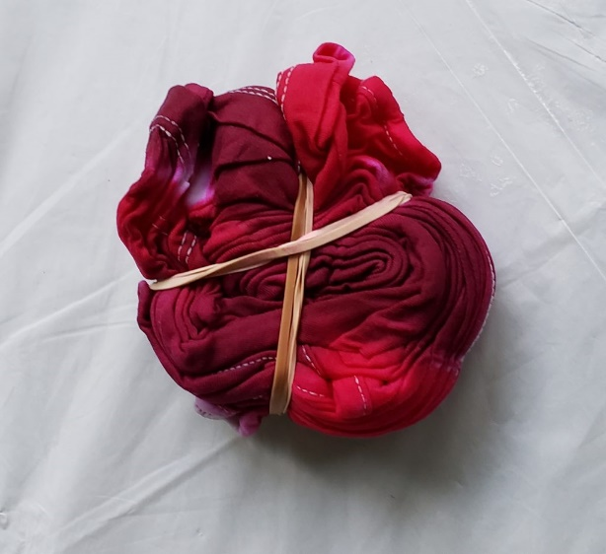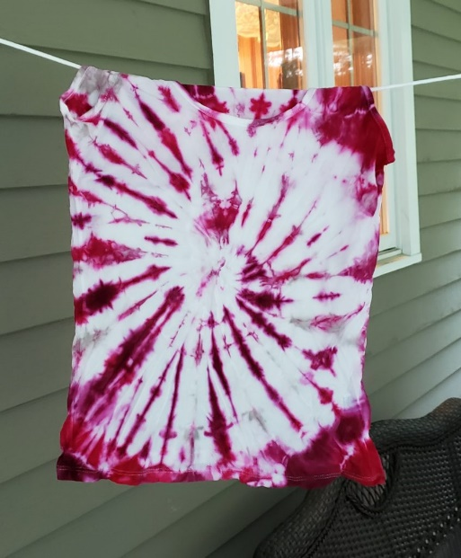

To make the pattern below. Fold shirt into squares, accordion style, then bind the shirt with 4 elastics, near the edge of the square on each side, forming a shape like a frame. Cover each edge of the "frame" (along back and front and edges of the fabric) with dye, overlapping on the corners. Leave the center of the square blank.
